Manav Rachna International Institute of Research and Studies
Department of Computer Science and Engineering
BTech CSE

Hotel Room Booking System

Group Members:
Tanish chauhan(1/24/SET/BCS/038)
Dheemant (1/24/SET/BCS/035)

Objective
The main objective of the Hotel Room Booking System project is to automate and simplify the process of booking hotel rooms for both customers and hotel staff. This system aims to manage room availability, store customer and booking details, and prevent issues like double booking or manual errors. By digitizing the booking process, it increases efficiency, saves time, and provides a convenient way for users to view, select, and reserve rooms. The project helps maintain organized records of all bookings and enhances the overall customer experience by making reservations easier and more reliable.

Introduction
The main objective of the Hotel Room Booking System project is to automate and simplify the process of booking hotel rooms for both customers and hotel staff. This system aims to manage room availability, store customer and booking details, and prevent issues like double booking or manual errors. By digitizing the booking process, it increases efficiency, saves time, and provides a convenient way for users to view, select, and reserve rooms. The project helps maintain organized records of all bookings and enhances the overall customer experience by making reservations easier and more reliable.

Features
The main features of the Hotel Room Booking System are:
- Simple user interface to view available rooms with details.
- Booking rooms by entering user details and dates.
- Real-time room availability check to prevent double bookings.
- Automatic updating of room status upon booking.
- Storing all bookings for reference and management.
- Option to view booked rooms and their details easily.

Flowchart
Here are the key points of the Hotel Room Booking System:
- Displays available rooms with details.
- Allows users to select and book rooms.
- Checks room availability to prevent double booking.
- Updates room status after booking.
- Stores booking information for management.
- Provides an option to continue booking or exit.
- Simple and user-friendly interface designed for beginners.

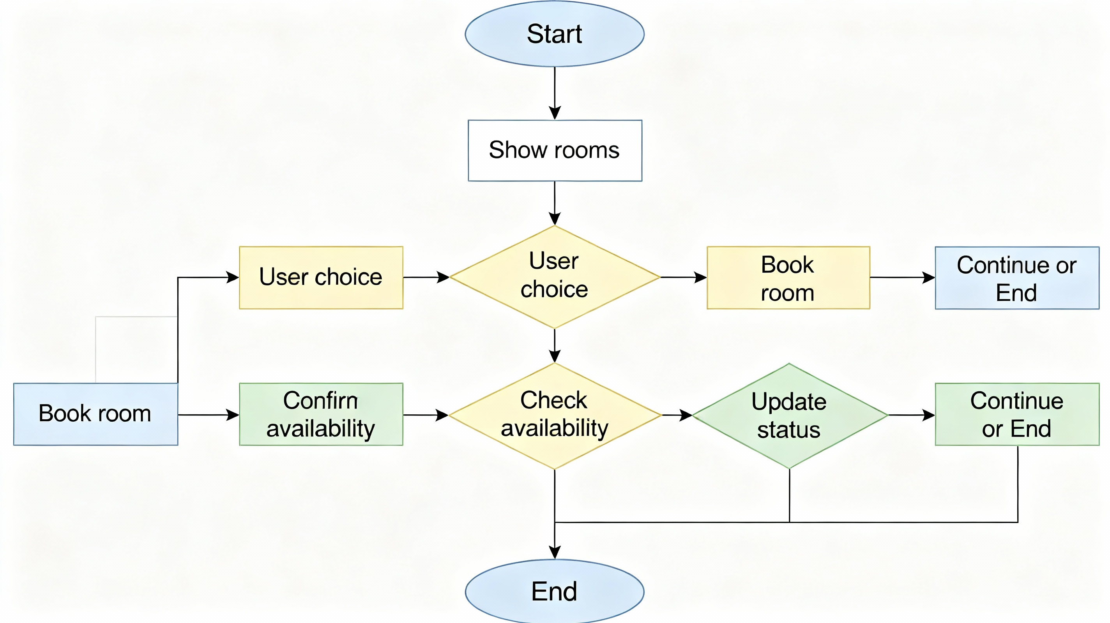

Code Explanation
The code works as follows: It defines a collection of rooms with their types, prices, and availability. Users can view all available rooms using the show_rooms function. To book a room, users input their name, desired room number, and check-in/out dates through the book_room function. This function validates room availability, updates the status to "Booked" if available, and saves the booking details. The main function allows users to repeatedly choose to view rooms, book a room, or exit, ensuring continuous interaction until they decide to stop. The program effectively uses basic Python concepts such as dictionaries, lists, functions, loops, and conditionals to manage hotel room bookings interactively and simply

Outputs (Simulated)
1. Show Rooms
2. Book a Room
3. Exit
Choose (1, 2 or 3): 1

Room ID Type Price Status
1 Single 1000 Available
2 Double 1500 Available
3 Suite 3000 Available

1. Show Rooms
2. Book a Room
3. Exit
Choose (1, 2 or 3): 2
Tell me your name:
Alice
Which room do you want to book? Enter room number:
2
Enter check-in date (YYYY-MM-DD):
2025-11-20
Enter check-out date (YYYY-MM-DD):
2025-11-25
You have successfully booked the room!
1. Show Rooms
2. Book a Room
3. Exit
Choose (1, 2 or 3): 1
Room ID Type Price Status
1 Single 1000 Available
2 Double 1500 Booked
3 Suite 3000 Available
1. Show Rooms
2. Book a Room
3. Exit
Choose (1, 2 or 3): 3

Thank you! Goodbye.

Conclusion / Learning Outcome
The Hotel Room Booking System project aims to automate the hotel room reservation process, making it easier and faster for customers to book rooms and for hotel staff to manage bookings. It reduces manual errors, prevents double bookings, and maintains organized records. The project provides a user-friendly interface to view rooms, book them with date inputs, and update room availability automatically. It helps improve operational efficiency and customer service in hotel management.
Learning outcomes include grasping programming basics such as data structures, functions, input validation, and control flow, as well as understanding project design and flow. It prepares students for more advanced software development through practical application of coding concepts in a real-world scenario.

